1 Night, 2 Days

Muscat – Ras al Hadd-Wahiba
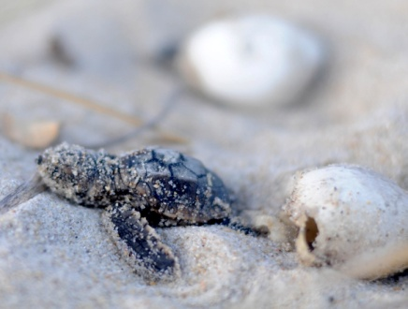
DAY 01 –
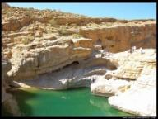
In the Morning The tour start with a short of Muscat city , then depart Muscat towards Sur through the Coastal Route, you will see Quriyat a small coastal fishing village and proceed for a photo stop at the Bamah Sinkhole ,Then we will continue along the white Beach of Fins where a beautiful white sandy beach beckons for a relaxing swim. The journey continues on the graded track to Wadi Shab, one of Oman's most spectacular wadis, flowing with fresh water most of the year alongside banana plantations and rocky paths. You can swim on through the warm waters from pool to pool, Tour continues to Sur and Ras Al Hadd where overnight stay is arranged. After dinner, we will drive you to Ras al Jinz Turtles sanctuary a protected Green turtle nesting reserve. Where you can see Oman`s great sea turtles on the beach nest and lay eggs, you have Possibilities to see baby turtles hatching from some nests.
Overnight stay in Ras Al Hadd.
(Lunch & Dinner Optional)
Day 02 -
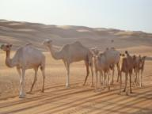
After Breakfast we continue to Wadi Bani Khaled . It is one of the biggest and most beautiful Wadis in Oman. Enjoy a refreshing swim in its coolwaters. Then we drive towards the Wahiba Sands to experience the magic of a true desert - almost a sea of constantly shifting sands. A drive through the inspiring sand dunes is a must. Enjoy the 4x4 dune-bashing and ride camels. Later, visit a local Bedouin family in their home to get a close up view of their lifestyle and share coffee & dates with the genuine Bedouins.
Late afternoon return back to Muscat
(Lunch optional)

Note: bring plenty of sunscreen, good shoes, and swimming trunks.

PRICE : From 465 USD per person ( min. 2 persons)

INCLUDES:
:Accomodation Double/twin room on sharing basis with breakfast
:4WD Vehicle with English speaking Guide/Driver
:Water/soft drinks enroute
:All entrance fees/permits.

